A First Look at Neural Networks

Lecture videos

Required video
But what is a neural network? | Chapter 1, Deep learning

Optional video
Gradient descent, how neural networks learn | Chapter 2, Deep learning

Now, let’s play around with some neural networks to build our intuition on how they work!

WARNING: Remember to create a copy of this worksheet first!

Setup: Tensorflow Playground
This worksheet requires us to tinker with a web application called Tensorflow Playground (https://playground.tensorflow.org). It hosts a small neural network that we can tweak the parameters of to try to build the best neural network for our data.
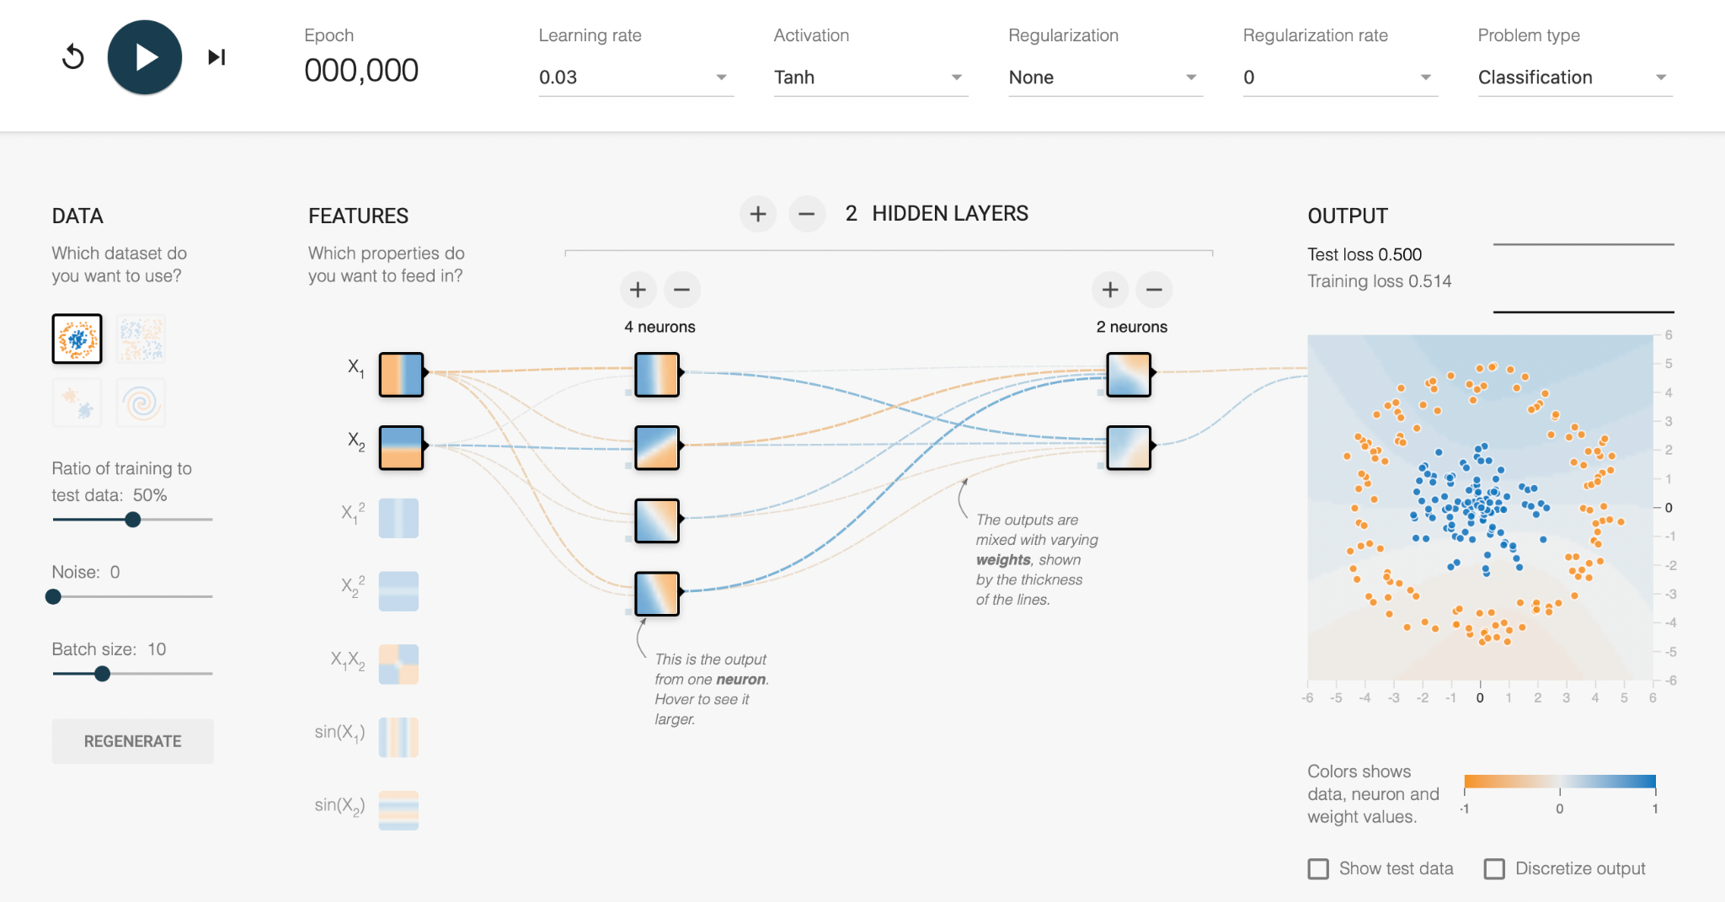

Activity #1: Building our vocabulary
Let’s begin by building up our vocabulary. Here are the definitions of some key terminology for machine learning. Your task is to find these terms in Tensorflow Playground.

Term | Definition | Locate on TF Playground
Data split | The process of creating three subsets of the full dataset to train, validate, and test the model.  - Training data: To train a model, we need to take a subset of the full dataset to “teach” the model.  - Validation data: While we are training the model, we need to test how well it is learning so far by using a different subset of the full dataset that does not overlap with the training data.  - Test data: After we fully train the model, we need to test (1) how well the model learned from the training data and (2) whether the model can perform well on never-before-seen data.  Remember that there should never be overlaps between these three sets of data. Otherwise, the model is able to cheat because it has seen those data points before (“data leakage”). | Fill in the blank
Batch size | When working with really large datasets, it is unlikely that the full dataset will fit into GPU memory. As a result, we create batches of the data. Batch size defines how large our batches are. | Fill in the blank
Classification | Predicting the class of a data point. These are usually discrete labels.  Examples: “apple”, “bicycle”, 0, 1 | Fill in the blank
Regression | Predicting continuous values of a data point.  Examples: Height or age of a person | Fill in the blank
Loss | Penalty for a bad prediction. The goal while training a machine learning model is to minimize the loss. If the model is perfect, the loss should be 0. Otherwise, the loss is greater than 0. | Fill in the blank
Layer | A building block of a deep learning model. Given input features, a layer transforms them into a new set of features. This new set of features should contain the most important information from the input features.  Features are information about each data point. They vary at each layer. Check the definition of “feature” for input, hidden, and output layers below.
Input layer | The first layer of a deep learning model. It takes as input the features of the input data.  Input: Features of the input data are numerical values about a data point. For example, a patient (data point) may have features about the patient’s age, height, etc.  Output: The new features output by the input layer are pieces of information that are most important about the data point for the overall prediction task. | Fill in the blank
Hidden layer(s) | The middle layers of a deep learning model. It takes as input the features of the previous layer.  Input & Output: Features are pieces of information that are most important about the data point for the overall prediction task. | Fill in the blank
Output layer | The final layer of a deep learning model. It takes as input the features of the previous layer to output the predictions for each data point.  Input: Features are pieces of information that are most important about the data point for the overall prediction task.  Output: Predictions for each data point | Fill in the blank
Activation function | A nonlinear function that transforms the features of each layer further to increase the complexity between data points. An activation function is usually added after each layer. | Fill in the blank
Regularization | A technique used to calibrate machine learning models to prevent overfitting or underfitting on the data.  Overfitting is when the machine learning model is able to perform well on training data, but poorly on test data.  Underfitting is when the machine learning model is not able to perform well on the training or testing data. | Fill in the blank
Regularization rate | A scalar used to adjust the impact of the regularization term. | Fill in the blank
Learning rate | A scalar used to determine the step size at each iteration to move towards a minimum of a loss function. | Fill in the blank
Epoch | Number of iterations to train the model. | Fill in the blank

Activity #2: Understanding neural networks
Now that we know some of the key terminology for machine learning, let’s understand how each component of a neural network works!

Let’s work with the first dataset (blue and orange dots are each organized in a circle, with the orange dots in the outer circle) for these questions. Start with the default settings:
- Learning rate: 0.03
- Activation layer: Tanh
- Regularization: None
- Regularization rate: 0
- Problem: Classification

Question 1: Epochs
- What happens to the model’s performance when you increase the number of epochs?
- What might explain why the number of epochs impacts performance?
You can increment epochs one at a time by pressing the button next to the play button.
Write your answer here

Question 2: Learning rate
- What happens to the model’s performance when you increase or decrease the learning rate?
- What might explain why the learning rate impacts performance?
- For our dataset, which learning rate(s) gives us the best performance?
Write your answer here

Question 3: Data noise
- What happens to the model’s performance when you increase or decrease the noisiness in the data?
- What might explain why noise impacts performance?
Write your answer here

Question 4: Batch size
- What happens to the model’s performance when you increase or decrease the batch size? (Hint: Try comparing a very small batch size to a very large batch size)
- What might explain why the batch size impacts performance?
- For our dataset, what batch size gives us the best performance?
Write your answer here

Question 5: Data split
- What happens to the model’s performance when you increase or decrease the ratio of training to test data?
- What might explain why the ratio of training to test data impacts performance?
- For our dataset, what ratio of training to test data gives us the best performance?
Write your answer here

Question 6: Input features
- What happens to the model’s performance when you change the input features? Try inputting the X₁X₂ features only (remember to turn off the X₁ and X₂ features).
- What might explain why the input features impact performance?
- For our dataset, what input features give us the best performance?
Write your answer here

Question 7: Hidden layers
- What happens to the model’s performance when you increase or decrease the number of hidden layers?
- What might explain why the number of hidden layers impacts performance?
- For our dataset, how many hidden layers give us the best performance?
Write your answer here

Question 8: Regularization
- What happens to the model’s performance when you change the regularization type?
- What might explain why regularization impacts performance?
- For our dataset, what kind(s) of regularization give us the best performance?
Write your answer here

Question 9: Activation layer
- What happens to the model’s performance when you change the activation layer?
- What might explain why the activation layer impacts performance?
- For our dataset, what kind(s) of activation layer give us the best performance?
Write your answer here

Question 10: New data, who dis?
- What is the model’s performance when you change the dataset but keep the same model parameters?
- Are the parameters that we chose based on another dataset the best set of parameters for the new dataset? Why or why not?
Write your answer here

